**DAILY ONLINE ACTIVITIES SUMMARY**

|  |  |  |  |  |  |  |  |  |
| --- | --- | --- | --- | --- | --- | --- | --- | --- |
| **Date:** | **12/07/2020** | | | | | **Name:** | **VANDANA** | |
| **Sem & Sec** | **IV sem & B section** | | | | | **USN:** | **4AL18CS095** | |
| **Online Test Summary** | | | | | | | | |
| **Subject** | | **-** | | | | | | |
| **Max. Marks** | | **30** | | **Score** | | | **-** | |
| **Certification Course Summary** | | | | | | | | |
| **Course** | **Predictive Modelling and Analytics** | | | | | | | |
| **Certificate Provider** | | | **Greatlearning academy** | | **Duration** | | | **5.5 hours** |
| **Coding Challenges** | | | | | | | | |
| **Problem Statement1:-------------------** | | | | | | | | |
| **Status: ----------** | | | | | | | | |
| **Uploaded the report in Github** | | | | | **-----------------** | | | |
| **If yes Repository name** | | | | | **------------------** | | | |
| **Uploaded the report in slack** | | | | | **YES** | | | |

**Online Test Summary: No internals Conducted Today.**

**Online Certification Course Summary: In Today’s session I have learnt about the Predictive Modelling Overview in Predictive Modelling and Analytics.**

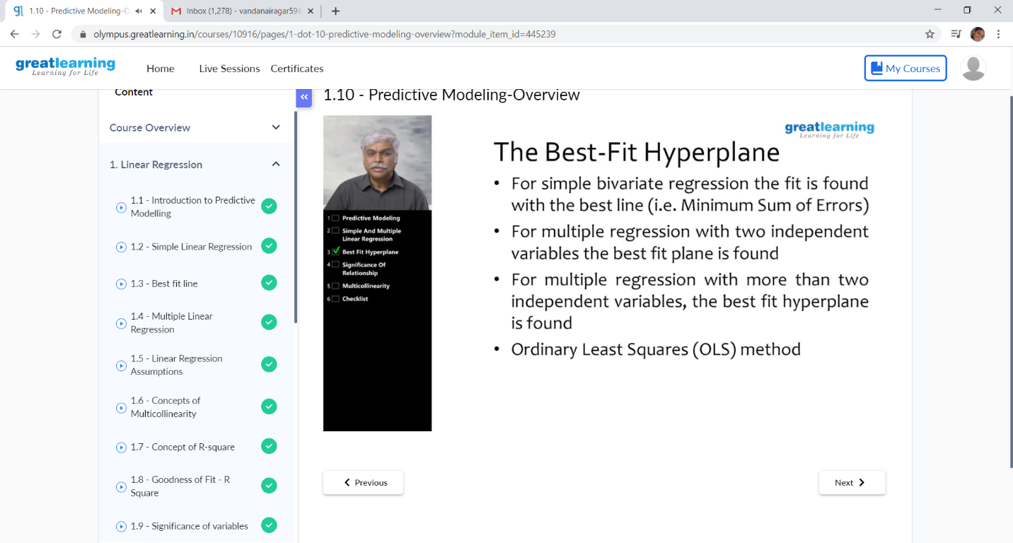

This is the snapshot of today’s session.

Online Coding Summary: No problem statements were given.